Title in English (Times New Roman; size-13; G; Interline 1,15)
Full professional affiliation | Specialty |  | Full name of the first author¹in two languages  (Times New Roman; size-12)  Professional e-mail address
Full professional affiliation | Specialty |  | Full name of the second author²  in two languages  (Times New Roman; size-12)  Professional e-mail address
DOI : 00.00000/0000-000-000-000 |  | ORCID:
Received: .../…/…… Accepted: .../…/….. Published:.../…/…..

Abstract:(Not more than10 lines)
An abstract is a brief and accuracy, it focuses on: research scope, objectives, Methods, results. An abstract is a brief and accuracy, it focuses on: research scope, objectives, Methods, results. An abstract is a brief and accuracy, it focuses on: research scope, objectives, Methods, results.
Keywords: …….; ………; ……; …..; …...
(Times New Roman 13; Interline 1)

_____________

Corresponding author: Full name, e-mail: ……………….@...................... .

1. INTRODUCTION
The first subtitle opens with an introduction that presents the specific problem under study and describes the research strategy. The first subtitle opens with an introduction that presents the specific problem under study and describes the research strategy. (Times New Roman13, interline 1.15)

2. First Title (Times New Roman13, G, interline 1.15)
2.1 First Subtitle (Times New Roman13, G, interline 1.15)
Enter here the text of first subtitle, Enter here the text of first subtitle, Enter here the text of first subtitle, Enter here the text of first subtitle, Enter here the text of first subtitle, Enter here the text of first subtitle, Enter here the text of first subtitle. (Times New Roman13, interline 1.15)
2.2Second Subtitle
Enter here the text of second subtitle, enter here the text of second subtitle, enter here the text of second subtitle, enter here the text of second subtitle, enter here the text of second subtitle, enter here the text of second subtitle, enter here the text of second subtitle.

3. Second Title
3.1 First Subtitle
Enter here the text of first subtitle, Enter here the text of first subtitle, Enter here the text of first subtitle, Enter here the text of first subtitle, Enter here the text of first subtitle, Enter here the text of first subtitle, Enter here the text of first subtitle.
3.2 Second Subtitle
Enter here the text of second subtitle, enter here the text of second subtitle, enter here the text of second subtitle, enter here the text of second subtitle, enter here the text of second subtitle, enter here the text of second subtitle, enter here the text of second subtitle, enter here the text of second subtitle, enter here the text of second subtitle.

Table 1. Table title (this is an example of table 1)
Test 1 | Test 2 | Results 1 | Results 2 | Total Results
15.21 | 15.21 | 15.21 | 15.21 | 15.21
18.58 | 18.58 | 18.58 | 18.58 | 18.58
11.14 | 11.14 | 11.14 | 11.14 | 11.14

Source:author’s name, year, page

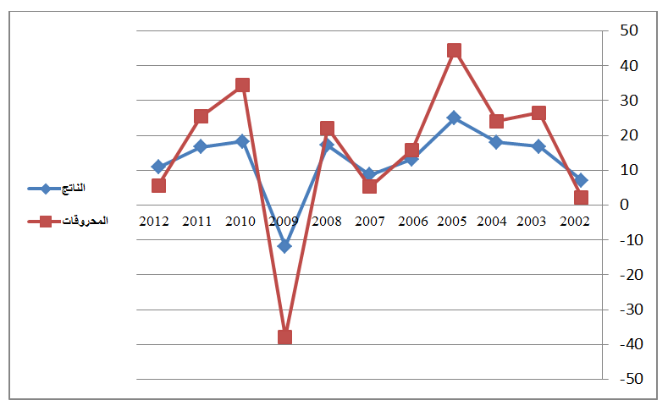
Fig.1. Figure title (this is an example of figure 1)

Source:author’s name, year, page

4. CONCLUSION
The conclusion of a research paper needs to summarize the content and purpose of the article. The conclusion of a research paper needs to summarize the content and purpose of the article.The conclusion of a research paper needs to summarize the content and purpose of the article. The conclusion of a research paper needs to summarize the content and purpose of the article. The conclusion of a research paper needs to summarize the content and purpose of the article. The conclusion of a research paper needs to summarize the content and purpose of the article.

5. Bibliography List :
Use the « APA Reference System », see the link :

https://www.youtube.com/watch?v=AmiKblUQs_A

The references must be directly quoted in the body of the text (eg: ... (Brown, 2006, p35), without omitting to mention the complete reference in the list of references at the end of the document,written in the following manner: (Times New Roman13 interline 1.15)
- Books : author’s name (year), full title, publishing, country;
- Theses: researcher, thesis title, college, university, country, year;
- Journal article : author’s name (year), full title of the article, review name, place, volume and number ;
- Seminar article: author’s name (year), full title of the paper, title of seminar, place and date, country ;
- Internet websites: author’s name (year), full title of the file, detailed web site :http://fulladdress (consulted on day/month/year).

6. Appendices

